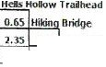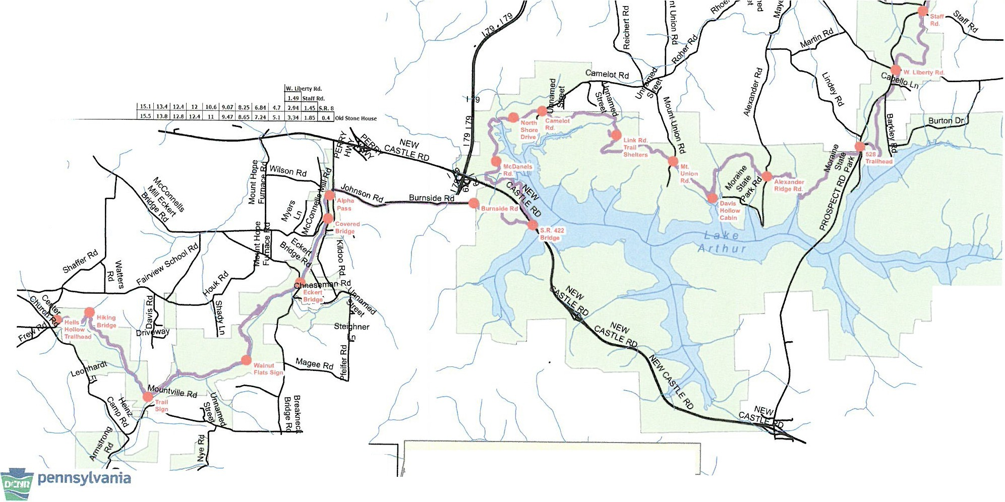...!.:.L .!!!!..!.Non Map Directions: The number located
..,. S.6) 3.93 ),IS Eckert6ridg,c two locations (indicated by dots on trail)
JIA M L ,t ···· -

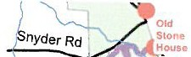4.13 3.41 1.78 Walnut Rats Sign on the chart at the Intersection between the ) )
/ -r - Y·
1.21 ,.,. .... '·"" 0.93 Covd Is the distance In miles between the two locations.
7.61 .... 5.16 ),48 1.3) ... AlnhaPu Please note the chart works from either 1/ Jl, (/ - \ -....-- oil/}
9.73 9.08 7.38 5.6 3.45 l..S.l. ,.u 6um Rd. starting location. (

10.9 lO.l 8.51 6.74 1.59 ,
3.16 1.14 S.R.4UBridge I .'<" - ;. . '1,.,

12.6 ll.9 10.J 8.16 6.ll 5.38 .... 1.86 1.7l: WcOtnd's Rd.
....
,... ... ,...
13.6 13 11.3 7,JJ • l.74 t.02 fforthShOl"CDri<rc
,...
14.1 13.4 IJ.1 9.91 7.11 6.H 4,)l J.18 1.46 1 .. Co111dol Rd.
...
15,4 14.8 13.1 11.J 4), 14 e:.11 7.81 4.SS UIJ 1.81 J.)7 tinkRd. TnlShfflen.
,,.. ....
,
16,9 16 J l4.6 12.8 10 7 9.72 9.31 1,1 6.06 4.34 J.3] LSI Mt. Union Wd.
..,.
11.1 IS.4 IJ.6 11. HU IO.I 11,ftl .16 4,14 J 7 7.l] 0.8) 0<1wir. Hoiow Cabtn
... ...
19.l 18.5 16.8 I> 12.9 11 11.6 9.0 6. 1 5.SS s.11 3.74 1.1] 1,411/Ucxi'tnder llidQc Rd,
, ,
ll.J 10.1 19 17.) 15 14,1 1].7 11.fi 10 4 R-71 7.15 4 )7 J.SS IU415J8lraihcikl
...
,
U.1 1:u 20.1 llU 16.8 15 9 l!i.S ll.] 11.J 10.) 9.45 9,01 6.13 ).J1 1 J.9 Iuc;I
14.6 1).9 22.l 10.4 18.] 17 l 16.9 14.8 Il.7 10., 10.5 9.11 1,61 u1,.,.11.,sl
"
15,-1 n.7 11.9 J .7 18.8 18.4 ti.]
"
16.."!... 2:,.a :14.1 11.) 10,1 19.] J_8,8 l_!.7

f

J
Legend L
\
----No'1·h=eountrylrail
\ l/

DEPARTMENT OFCONSERVATION
ANO NAnJRAL RESOURCES DKB
w, •,,Ju: .1,,it'P' 2128/2012

•Oi1,looce Maritorsllandma rtts
I I I I I I I I I

0 0.5 1 2 Miles
6
N

North American Datum 1983
Lambert Conformal Conic
PA South

