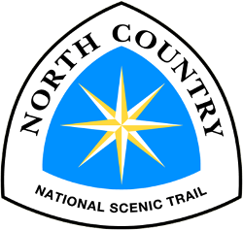
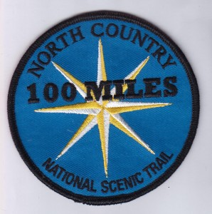

King Beaver Spring Camporee 2016
“HIKE 100 CHALLENGE”
April 22nd-24th
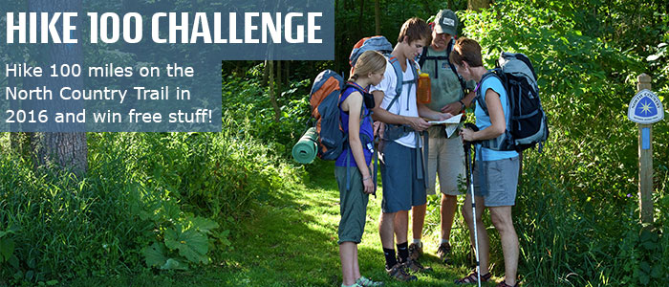
In 2016, the National Park Service is celebrating their centennial anniversary, and everyone can take part in the 100 miles for 100 years celebration! The centennial will kick off a second century of stewardship of America’s national parks and engaging communities through recreation, conservation, and historic preservation programs.
Anyone who hikes 100 miles on the North Country Trail during the calendar year of 2016, in aggregate or all at once, will be eligible for a special patch and certificate.
SCHEDULE:

*Units must bring their meal supplies

Friday: Arrive, set up camp, register at Easy-Up Tent starting at 6:30-8pm. Enjoy free time, organize gear, plan your hike.

8:30am –Leader and SPL meeting, register hike plan, arrange shuttling

Saturday: Rise and Shine for breakfast and prepare for the hike.

8:30am- Opening Ceremony, shuttle arrangements

You will need to prepare your own lunch.

4:00pm- Demonstration/Speakers from North Country Trail “Search and Rescue”

5:00-7:00pm- Prepare and eat dinner. Clean up

7:00pm- Demonstration/Environmentalist Speaker

8:00-8:30pm- Scout Vespers

Sunday- Pack up campsite and return home

King Beaver District
“Hike 100 challenge”

Location: Moraine State Park
Dates: Friday, April 22nd –April 24th
If you are coming Saturday, Check-in at Easy Up Tent 8:00-8:30am
Contact Cindy Myers to Register:
- Office phone (724)-287-6791 or Email cindy.myers@scouting.org

Cost per person: $10 Extra Patches: $2

Troop #______ Contact:_________________________
Email Address:___________________ Phone:__________

Pre-Registered Actual

Pre-Paid ______
Actual Cost ______
TOTAL DUE ______
Youth Count ______ _____ Pre-Paid

Adult Count ______ _____ Actual Cost

Extra Patches - $2 ______ _____ Total Due __

REFUND
Unit Account _______
Checks _____ Cash _____

Comments or Special Requests:______________________________________________________________________________________________________________________________________________

Starting your Hike 100 Challenge is easy!
(Download this Hike 100 Challenge flyer here to share with your friends. Download: Hike100Flyer)
  - 1. Sign up for the special e-mail list.
  - Click the button below to sign up now:
  - Sign Up for Hike 100!
  - By signing up, you’ll be entered for fun giveaways and cool prizes. We’re also working on a digital toolkit to help you track your miles. We’ll send it to you when it’s ready! Sign up to get these exclusive offers so you don’t miss out.
  - 2. Start planning your hikes.
  - Take a look at our online map, and start planning your adventures for 2016.
  - If you don’t want to hike alone or would appreciate hiking with local NCT experts, check out our online calendar of events.
  - 3. Invite your friends.
  - Share this challenge with your friends and hike together!
  - You can also share the calendar of events with your friends and family and encourage them to tackle the Hike 100 Challenge too!
  - 4. Starting January 1, 2016, begin tracking your miles.

  - Every time you go out on the Trail, whether you’re by yourself, with friends, or doing work on the Trail as a volunteer, keep track of those miles. They will add up fast!
  - 5. Share your adventures with others on social media, #Hike100NCT.
  - Show us your pictures and stories using #Hike100NCT. Follow us on Instagram, Twitter, and on Facebook. You might see your pictures and stories featured on our pages!
  - 6. Once you’ve logged 100 miles, let us know!
  - Fill out this form to let us know you’ve completed your miles. We’ll get your patch and special certificate in the mail right away.
  - 7. Wear your patch with pride.
  - Seriously. You’ve earned it.

